**Lab#7**

**Circuit and System**

**Spring 2021**

Submitted by: **Maaz Habib**

Registration no:**20PWCSE1952**

Section: **c**

Submitted to: **Eng. Faiz Ullah**

**Department of computer Systems Engineering**

**University of Engineering and Technology Peshawar**

**Experiment # 7**

**Verification of Node Voltage Method using PSPICE**

**Objectives:**

* How to calculate node voltages of a circuit.

**Node Voltage Analysis:**

Nodal Voltage Analysis finds the unknown voltage drops around a circuit between different nodes that provide a common connection for two or more circuit components.

**Node:**

Those junctions point where more than two branches are met or join, so these are Nodes. And there is a difference between node and corner points.

**How to apply KCL?**

We apply KCL in order to find the voltages inside the circuits. Whenever we apply KCL on nodes we imagine first the current directions across the nodes. After that we write the equation where we apply KCL. But one thing is very important that whenever we take the values of current, so we should take the entering current Negative and Leaving current is Positive so it will so easy for us to calculate the voltages.

**Circuit Diagram:**

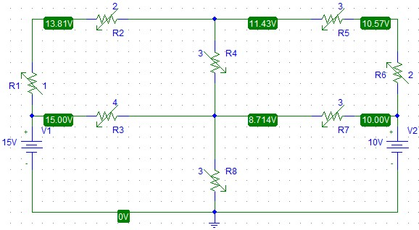

**Apparatus:**

* Computer with PSPICE installed

**Procedure:**

1. Open schematic program of PSpice
2. Click on the “Get New Part” button on the toolbar
3. Type ‘r’ in the search bar and place the eight resistors on the white sheet
4. Type ‘vdc’ in the search bar and place two of them on the white sheet
5. Type ‘gnd-earth’ and place it on the white sheet
6. Now arrange these components on the white sheet according to the circuit diagram as following
7. After arranging click on simulate button and the following results are generated

**Procedure that how we find the voltages in easy way:**

* Find total number of nodes.
* Select the reference node.
* Identify the easy nodes, easy node means that their voltages already known.
* Identify the current directions.
* Apply KCL on nodes.
* After applying the KCL convert this into the ohm’s law form.

**Now we will find some unknown voltages by KCL:**

**Observation and Calculation:**

**Table:**

|  |  |  |  |  |
| --- | --- | --- | --- | --- |
| S.no | Resistor | Current | Voltage drops at resistors | Voltages at v1 and v2 |
| 1. | 4Ω | 4A | 16V | V1= 16V |
| 2. | 2Ω | 8A | 16V | V2=32V |
| 3. | 8Ω | 4A | 32V | N/A |

**Circuit Diagram:**

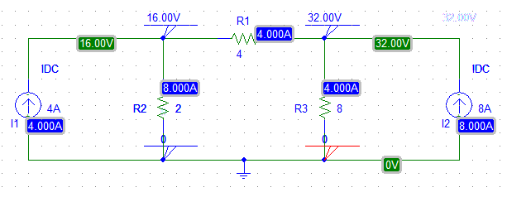

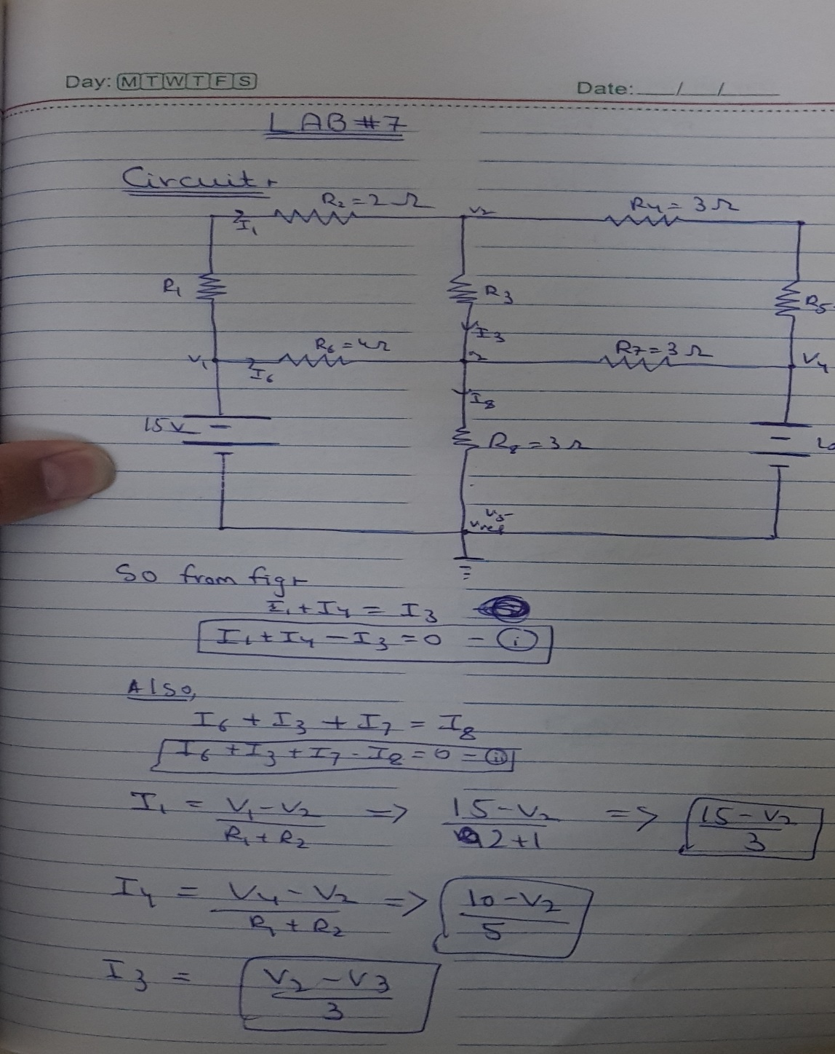

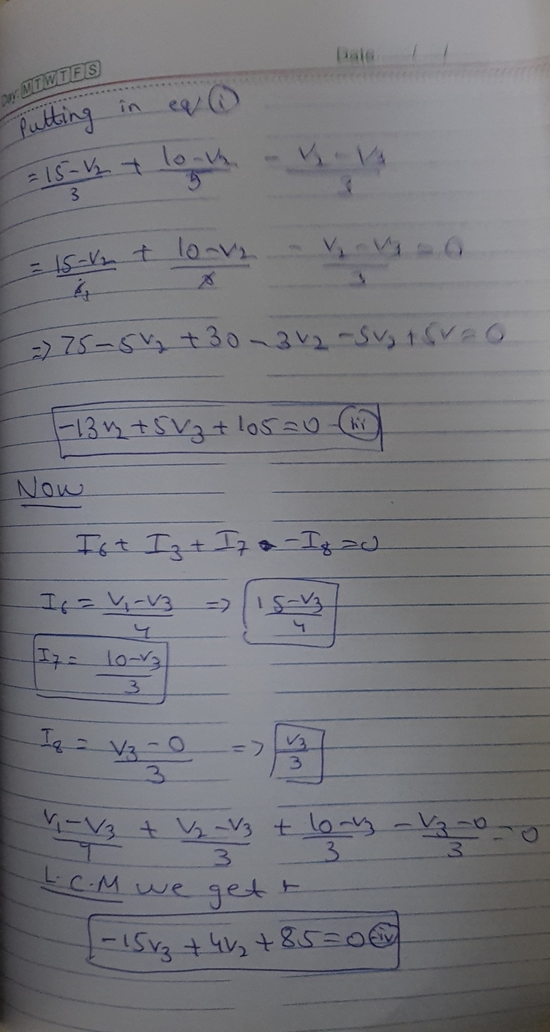

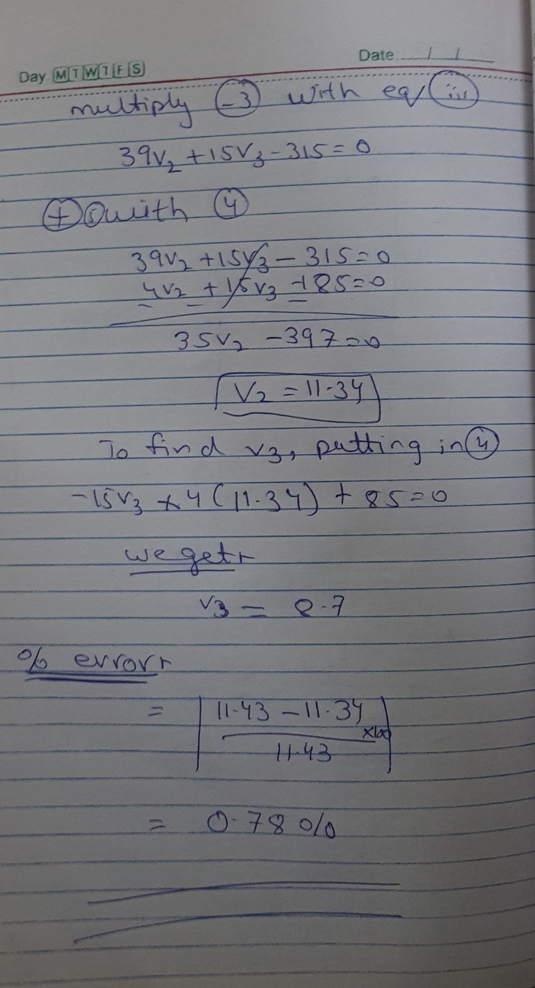

**Conclusion:**

Hence, we find the voltages across node v1 and node v2 and the answers are same in PSPICE and also same in my note book. And in the above circuit KCL also proved because entering current in a node is equal to leaving the node.